Game of Thrones

*8 characters - 8 life lessons.*

Game of Thrones: A fantasy thriller period drama takes the viewers to its own world of seven kingdoms. Apart from entertainment, if we see and observe crisply each character portrayed, they have one life lesson in them. George R.R Martin depicted each character very nicely and neatly.

From love to lust, from family to foes, from powerful to weak, from beauty to beast, from treaties of peace to wars, ask for anything, and GOT will place meticulously in your plate of eyes.

Many of the world’s other population who haven’t watched the series yet consider it as overrated or exaggerated but their statements and thinking take no time to reclaim when they actually start watching it.

Below mentioned are some characters of the series observing which we can assimilate something in our life.

1. Ravens:-

Ravens are black feathered birds used substantially for the purpose of conveying a message between the citadels and kingdoms of Westeros. They travel through extreme conditions. Once in the chilling winters of Winterfell and once in the hot summery days in the king’s landing.This shows that be like ravens. Be adaptable to every situation in which life has kept us in. If a Raven couldn’t cope up and settle in drastically changing weathers around the seven kingdoms then imagine how difficult it would be to communicate with the people. Just like, imagine how hard it will be for us to communicate and convey our thoughts if we don’t adopt the society around us.

**Be Like a Raven**

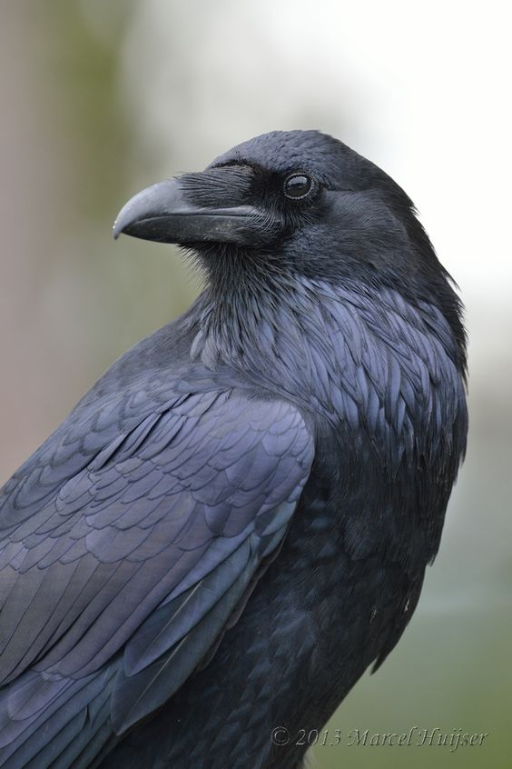

1. **Cersei Lannister (Lena Headly)**

A lady who can do anything, (highlight the word anything) for the protection of her family. She is one of the heirs to house Lannister in king’s landing and present Queen of the seven kingdoms. There are ample amount of things to grasp from her role but the one which tops the list is her dialogue

*Everyone who isn’t us(family) is our enemy.*

*The more people you love, the weaker you are.*

She turns into a badass vindictive lady when it comes to her family. *This manifests the love for the family. No matter how good your relationship may be with your best-friends or so-called friends but at the end of your day, it's your family who stands beside you in every situation.*

Isn’t she admirable as a villain?

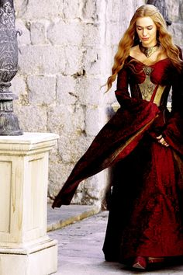

1. **Arya Stark (Maisie Williams)**

The younger sister to the stark brothers and daughter of Ned and Catelyn Stark, Arya was horrified and confused when her father was executed in front of her eyes in the king’s landing. She had two choices- either give up and be a prisoner and die in the hands of lannisters or to run away, prepare and avenge her father’s murder.

She roamed around the world, trained to be a badass warrior and came back to her home with a list of to-be-killed. *Similarly, a phase will come in our life when we are confused and can’t see the road ahead. The only thing to be done at that time is to* ***not give up.*** *If she had given up, the story would have been a way different and miserable.*

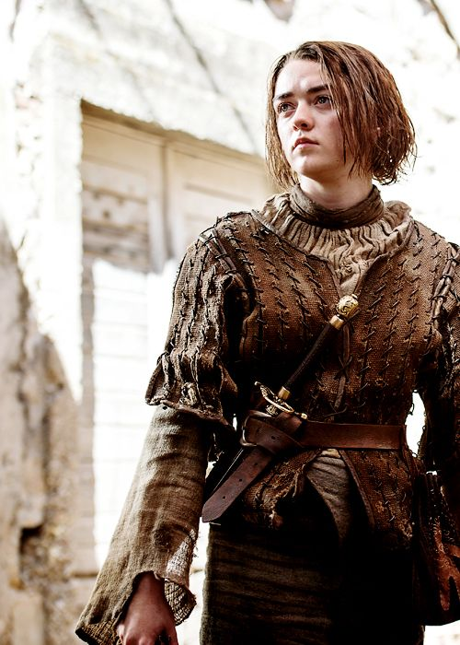

1. **Samwell Tarly (John Bradley West)**

A stout heir of House Tarly who was forced to guard at Night’s watch as a manifestation of disregard and inheritance. Serving them, he met Jon snow who helped him fight his own struggle at nights watch and they became good friends. After some time he fled the night’s watch to become a master. There he learned about the originality of the plot (though he was wrong) Even after so many rifts coming through his life, he never forgot his friend and came to Winterfell to help Jon at the time of crisis. His loyalty to Jon not only saved them but it is assumed that many lives can be saved now with the help of his knowledge of Dragon glass. *So, do I need to elaborate now? Because this quality should be inherited by each in this world:* ***Loyalty. Period.***

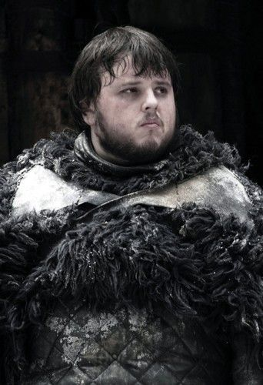

1. **Brienne of Tarth (Gwendoline Christy)**

Belonging to House Tarth and an ally to House Stark, she is a fierce warrior and the only daughter of Selwyn Tarth. Formerly she was pledged as a kings guard to Renly Baratheon. After Renly’s homicide, she was vowed later to protect Lady Sansa of House Stark by Catelyn Stark. She was nearly raped and murdered during her search for Sansa, Still, by hook or crook, she found her and completed her duty by rescuing Sansa from Bolton army. ***Adherence and to comply with the promises given is what she can teach us.***

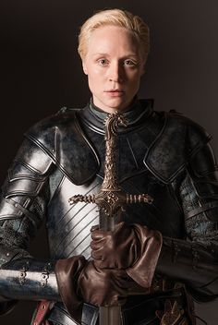

1. **Ser Jorah Mormont (Iain Glen)**

The Heir of Night watch’s commander Jeon Mormont Jorah was in exile when he met Danearys Targaryen and became her advisor and close acquaintance. While working for her he fell in love with her, of which he was nicely denied of. On his odyssey with Tyrion, he came in contact with infectious diseases. Destiny played an important role while in case of Jorah and Samwell Tarly was successful in curing his diseases. Now he had two choices- Either go back to the woman whom he loves to head over heels or can start a new life. He didn’t give up and went back to help and assist Danearys. ***Either be one-sided or two, love has unfathomable powers that can build one’s life. This guy here is a perfect exemplar of the feeling of love.***

You must be thinking how love can be a life lesson. Life is one, go roam around, fall in love, rise above the horizon hand-in-hand with your partner. And if not, you will at least learn while you fall.

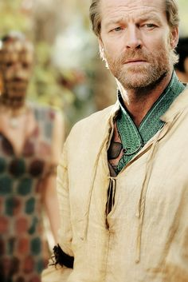

1. **Brandon Stark (Isaac Hempstead Wright)**

The second son and Heir of House stark, Brandon was pushed away by Jaime Lannister from Winterfell’s guard tower. But in the failed attempt of murder, Brandon became crippled for his remaining life. The story pulls over and with his personal struggles with his crippleness, Brandon was successful reaching to the three-eyed Raven and gained the training in becoming the one. Imagine if he just had passed out and gave it up to the fate and totally dependent. Though he was dependent on *Hodor* and two other people. Could he be a Three-eyed Raven? Could we be apprised of the disturbing fact of Jon Snow? No, right. ***If life has emptiness of dark cavern than it also has soothing mellows of sunshine on the top of the cliff. Many anecdotes will come, after which we won’t be the same. Learn to accept the way we are and let the journey continue.***

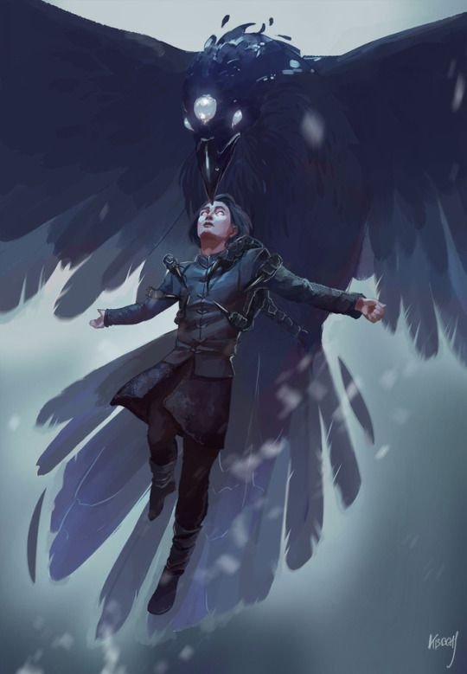

1. **Tyrion Lannister (Peter Dinklage)**

Deceased by family, ostracized by society, a born dwarf still the greatest and the smartest player in the Game of Thrones. He has myriad of haters and even her sister looking for his head. Still manages to scurry away from homicide attacks and be safe. The reason why he manages to do things he wants is he keeps asking people one question, *“What do you want?”* and people blurt out their deepest desires kept hidden in their hearts. ***Size doesn’t matter. Keep your eyes and ears open when in trouble, and know the interest of your ally and provide them with the same. Tyrion is the most admirable and famous character portrayed by the writer. Because in Game of Thrones, you win by your mind and not by your strength, and who better than Tyrion can explain it well?***

